Trespasser

Bugs by Fredrick Östlund



**Unclear mission objectives.**

It’s unclear what to do or what the mission objectives are. The information about where to go and what to do next is just in text form in the beginning and is very briefly presented. There are no signposts or other information about what to do, and there is no way to have the information repeated.

1. Start the game

2. The information about what to do is presented in the upper part of the screen very briefly.

3. If the player doesn’t pay attention to this information, or doesn’t remember it, the player has no way to find out what to do next.

**The input from “the arm” is imprecise when picking up gun/s.**

If the “the arm” is moved too fast and the right mouse button is not pushed accurately it is possible to knock down some or all of the guns to the ground etc. The tactility is unnatural, and the weight of the guns isn’t realistic. Even if one could do this, it’s probably something one shouldn’t do.

1. Go to the gun/s on the boxes.

2. Hold the left mouse button to use the “the arm”.

3. Move “the arm” towards the gun/s.

4. If the player is not in position to reach, step forward.

5. If “the arm” touches the gun/s, it will sometimes knock them down

**Fatal system error**

At startup the game immediately crashed and also caused a fatal system error. The screen went black with RGB stripes. The system had to be restarted.

1. Start the game

2. The screen went black with red/green/blue stripes.

3. The computer must be restarted.

**Poor collision detection between the rifle and the box it was placed on.**

If the player forces the light brown rifle loaded with 20 rounds to the box it was placed on, and drops it, it sometimes falls through the box. See pictures.

1. Go to the guns placed on the wooden box rightmost on the heliport platform.

2. Use “the arm” holding left mouse button.

3. Pick up the rifle with 20 rounds holding the right mouse button

4. Push the rifle to the box by walking toward it

5. Press right mouse button to drop the rifle. (Sometimes player drops the gun anyway)

6. Occasionally the rifle will fall through or partly into the box.

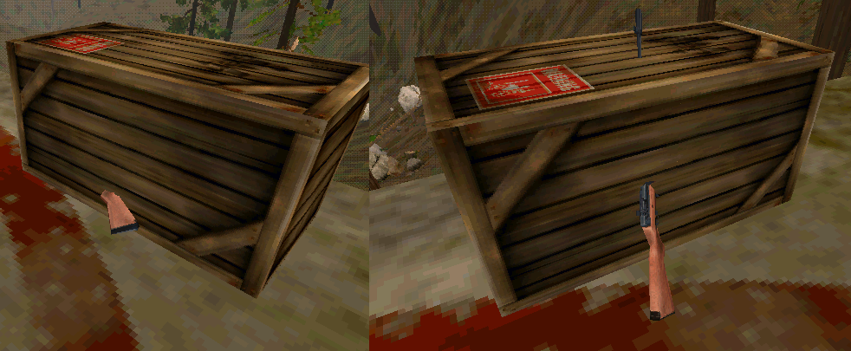

**The player gets stuck in the platform**

If the player jumps from the boxes of the starting platform and lands on the “metal” part of the other platform one can get trapped. The “metal” is on the edges of the platform, and appears to be former components of the bridge between the two platforms. See picture.

1. Climb the boxes on the starting platform.

2. Jump to the other platform

3. Try to land on the “metal” edge of the heliport.

3. Sometimes the player will get stuck

**Poor collision detection between platform and gun**

If the SMG gun next to the revolver on the first box is thrown to the platform floor it will occasionally fall through it and land on the ground beneath it.

1. Stand on the second heliport platform.

2. Equip the gun.

3. Aim the floor of the platform.

4. Push the F- button to throw the gun.

5. Sometimes the gun will fall through the platform.

**Twisted repertoire**

If the player holds the Shift-button and the left mouse button and at the same time rotates the mouse to the left or right “the arm” also starts to rotate. If this is done for some time “the arm” will twist itself 360 degrees. If this would be done on a “real arm” this should cause a bone fracture.

1. Hold the left mouse button to use “the arm”.

2. Hold Shift-button.

3. Rotate the mouse.

4. The arm starts to rotate.

5. Eventually, if this is done persistently, “the arm” should twist 360 degrees.

